Case Studies

Kuni Dehury, a resident of Kardapal village in Odisha’s Keonjhar district, runs a silk spinning centre. The major factor that makes the centre unique is the application of solar power to run it. The centre uses Reshamsutra’s solar-powered reeling machines because of which women do not have to bear the burden of electricity bills or the labour-intensive thigh reeling process. Kuni Dehury was also praised by Prime Minister Shri Narendra Modi in his ‘Mann Ki Baat’ programme for her outstanding efforts. Reshamsutra is a PL-supported enterprise to upscale solar reeling machines and help rural women silk-reelers.

Bilaspur Prison Project – training and employment of women inmates

Resham Sutra along with it’s partner NGO, Astitva Mahila Samiti, Bilaspur, organized training for 15 inmates of Women Cell of Bilaspur Central jail in 2017.

The selected women were convicted of oﬀences like murder, burglary and human/child traﬃcking, with sentences of 8 years or more. Typically these women were stigmatized in society even after being released from the prison and were abandoned by their families.

We worked with the prison authorities to design the program. The women were able to earn regularly during the prison term and save money for use after their release. On completion of their term, 3 out of 5 women expressed their willingness to continue the work. Some of them were employed as trainers with our organization and continue to work. They have taken up Silk production and have encouraged other women in their community to join the activities.

Subsequently the project was supported by the prison authorities and scaled up to additional 100 women prisoners.

Motivation changed their life
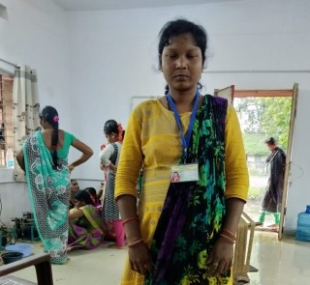
Ms. Bharati Sarathy, 27 years, received Silk spinning training and counselling from Resham Sutra’s partners in Bilaspur Prison.
“Spinning of tasar cocoons has given momentum to our perished life, and provided me an identity in the society since I am no more a burden to the family; instead, I can support them with earning of my own from a legitimate yet rewarding activity”, she tells.
Ms. Amar Bai, aged 46 years, has also joined the NGO as a trainer to the landless womenfolk. Training in jail on spinning of tasar cocoons for 15 days instilled conﬁdence in me. After training, we worked for 4-5 months more, and that improved our eﬃciency and productivity. “We are no more identiﬁed by quadi no. now we are known by our work that got us a name”.

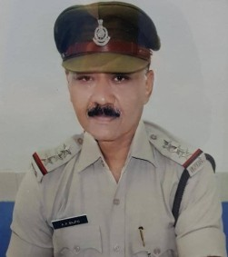
A remunerative avocation
Shri A.K. Bajpai, Assistant Superintendent, Central Jail, Bilaspur, Chhattisgarh tells that 15 women prisoners trained in spinning of tasar cocoons, expressed happiness over the livelihood opportunities that the skill may provide them, once they are released from the jail and also bring them out of depression.
Since tasar cocoon production is a major activity in the state, its reeling and spinning will continue to prove a remunerative avocation for sustenance to the womenfolk in the rural areas. He also believed in extending the training on tasar reeling and spinning to other jails in the state.

